**Name: Qianzi Xu (Rachel)**

**CMSC110 Introduction to Computing  
Assignment#4 (Due on Thursday, November 6, 2014)**

**Description and Thoughts**

Figure 1: Energy Use per capita for US and Canada (Rachel Xu)

A curve graph that describes the energy use (i.e. use of primary energy) per person for both US and Canada

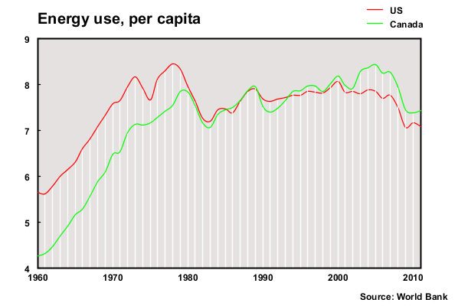

**[Insert your Image here]**

**This graph includes data (visualized in smooth curve and vertical lines) for both US (red) and Canada (green) from 1960 to 2011. Hovering the mouse around any data point, there will be a corresponding text display in the format of “year: energy usage” and the line under the data point will turn red or green depending on which curve the mouse is hovering on.**

**The process of visualizing the data was also the process of creating and correcting lots of mistakes. The biggest obstacle I encountered was designing interactivity. I examined my code very closely without any clue which part might be erroneous until Prof. Kumar told me the mistake was probably caused by inconsistencies in the mapped value of the data. This was something that I didn’t pay attention to at first (I mapped the data twice, one for reference throughout the program, the other for the drawCurve function) and suggested a need for improvement of the code structure. Other mistakes appeared in iteration (which caused failure in mapping and cost me a lot of time to fix) and curveVertex function (forgot to include both ends twice while iterating through the array). Also, some of the code are somewhat redundant and messy. It’s not hard to follow the professor in class yet when I was completely on my own, all kinds of problems that I had never thought of kept appearing and challenging me. Fixing all those problems was a little bit annoying but also the most important (and in some way enjoyable) part of the whole process.**